WEBSITE LAYOUT
No of tabs:
- Home
- Committee
- Scientific program
- Abstract submission
- Registration
- Visitor’s information:
- Venue
- How to reach
- Culture and cuisine
Committee Page:
Organizing Committee:
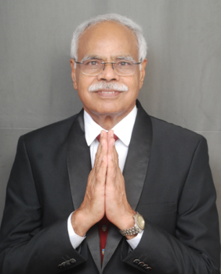
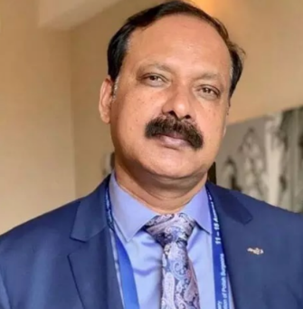
Patrons

Prof. Bhupendra Kumar Singh Sanjay President
Dr. Ashok Puranik Executive Director

Co-Patrons
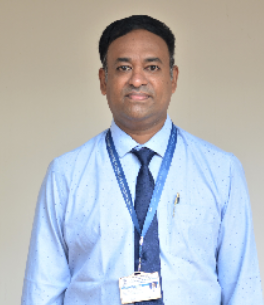
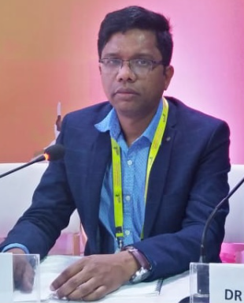
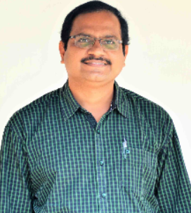

Dr. Naveen P Dean Examination
Dr. Bhupen Barman Dean Research
Dr. Muralidhar Reddy Sangam Dean Academics

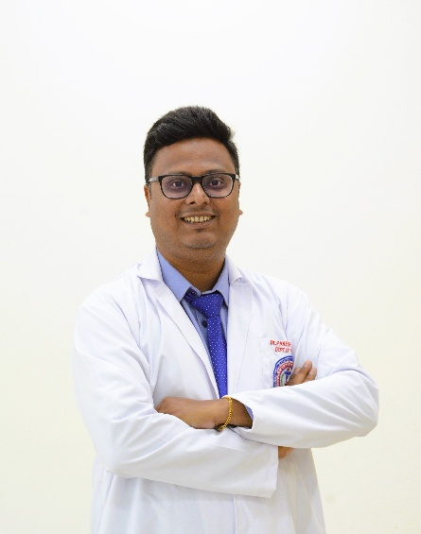
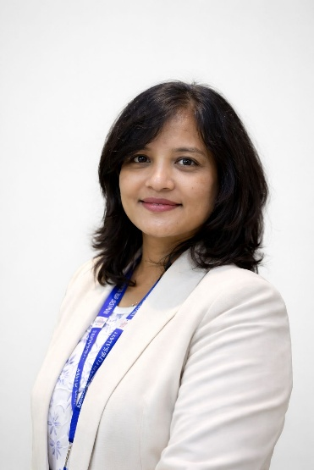
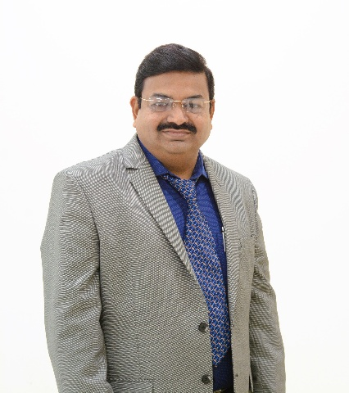

Dr. Aseema Das Organising Chairperson
Dr. S.P. Sinhasan Organising President
Organising Secretary

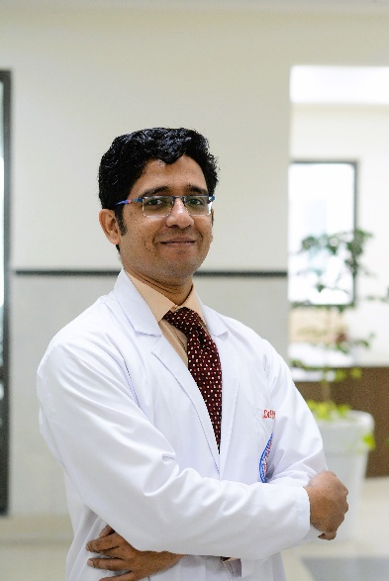
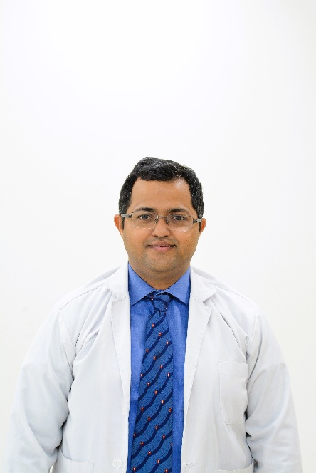
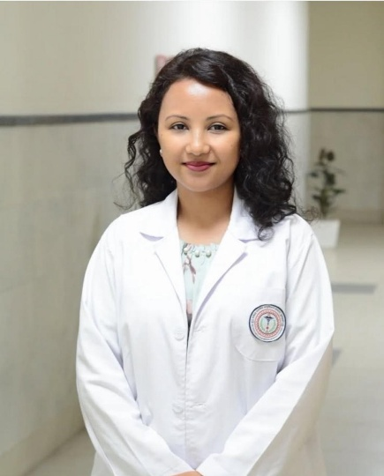

Treasurer
Souvenir Committee
Scientific Committee

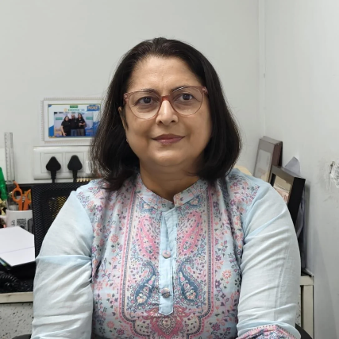
NERCON OFFICE BEARERS
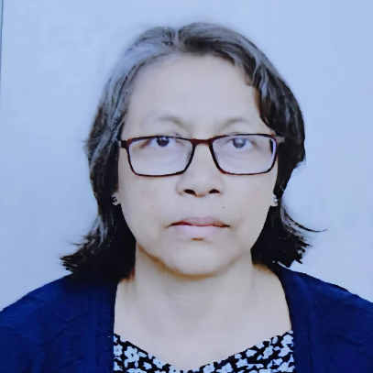
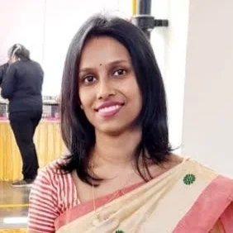

Dr. Riju Rani Deka General Secretary
Dr. Yookarin Khonglah Vice President
Dr. Ronica Baruah President

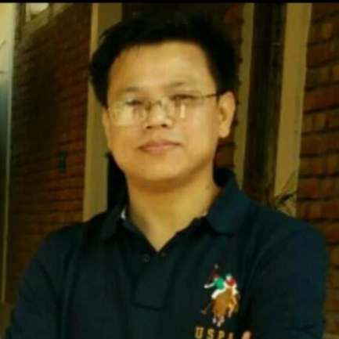
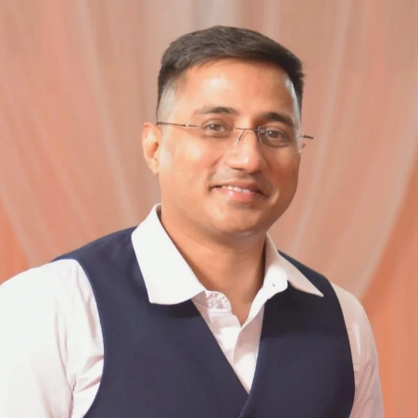
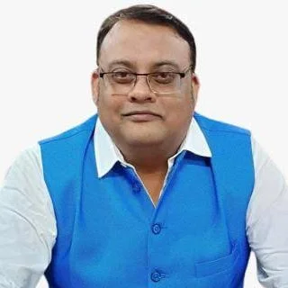

Dr. Bedanta Bhuyan Joint Secretary
Dr. Bipin Th Joint Secretary
Dr. Naushad Shah Treasurer

Senior Residents:
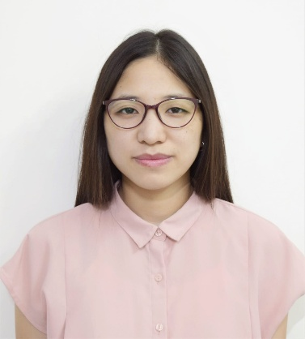
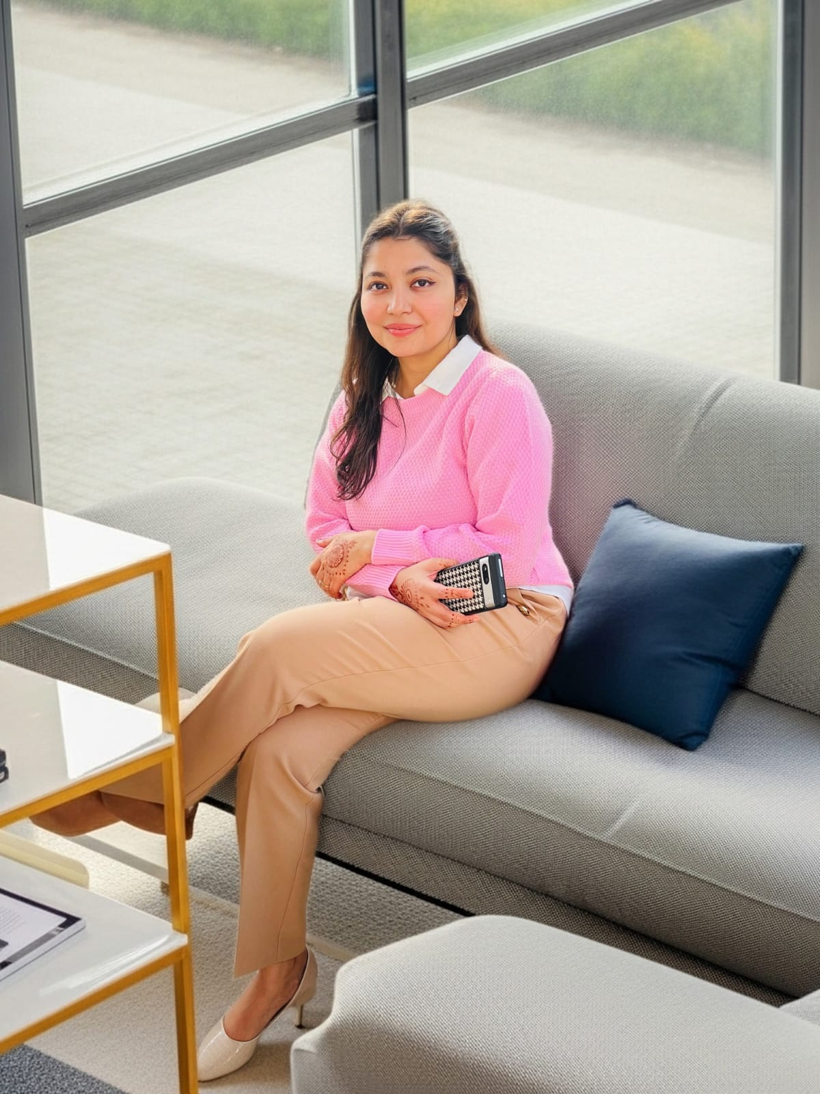
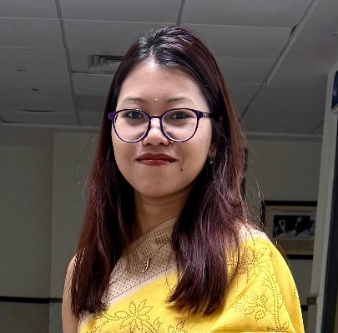

Dr. Nuneno Nakhro
Dr. Aditi Bhattacharya
Dr. Thangjam Ruchika

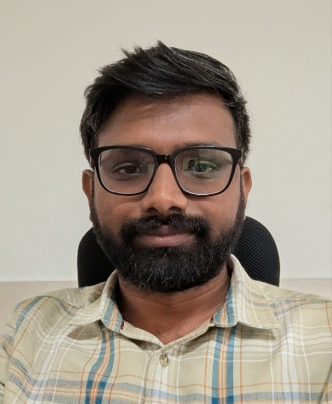
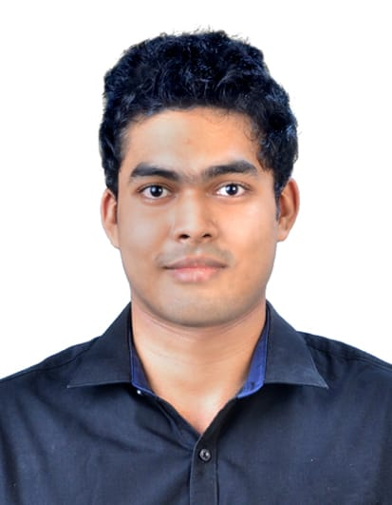
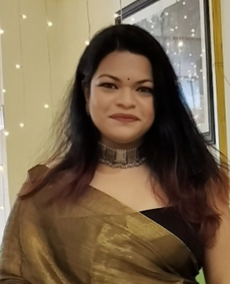

Dr. U.S. Ananthnarayan
Dr. Amrapali Sammader
Dr. George A
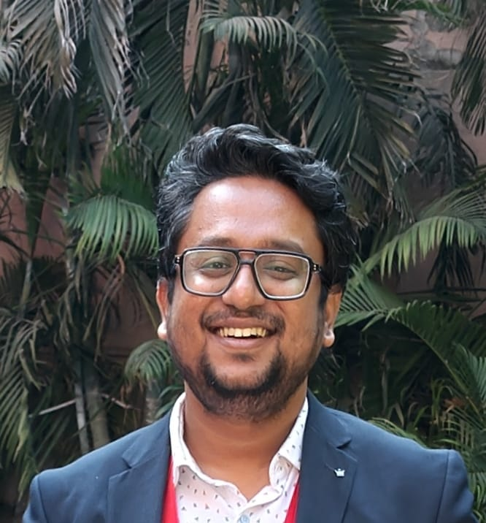
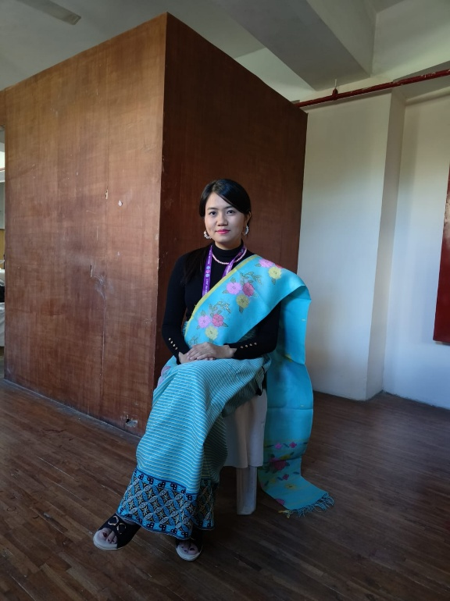
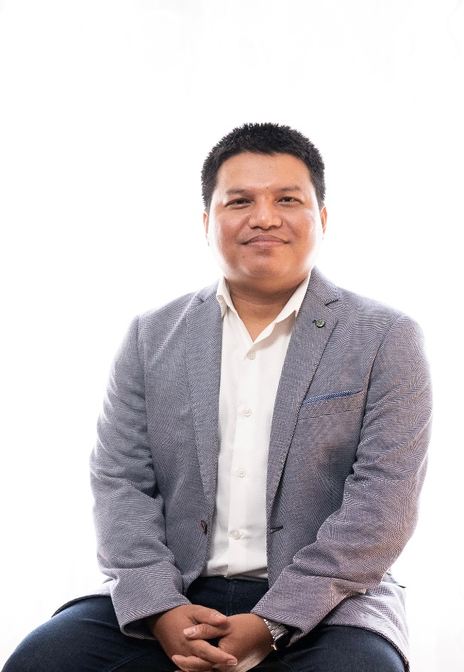

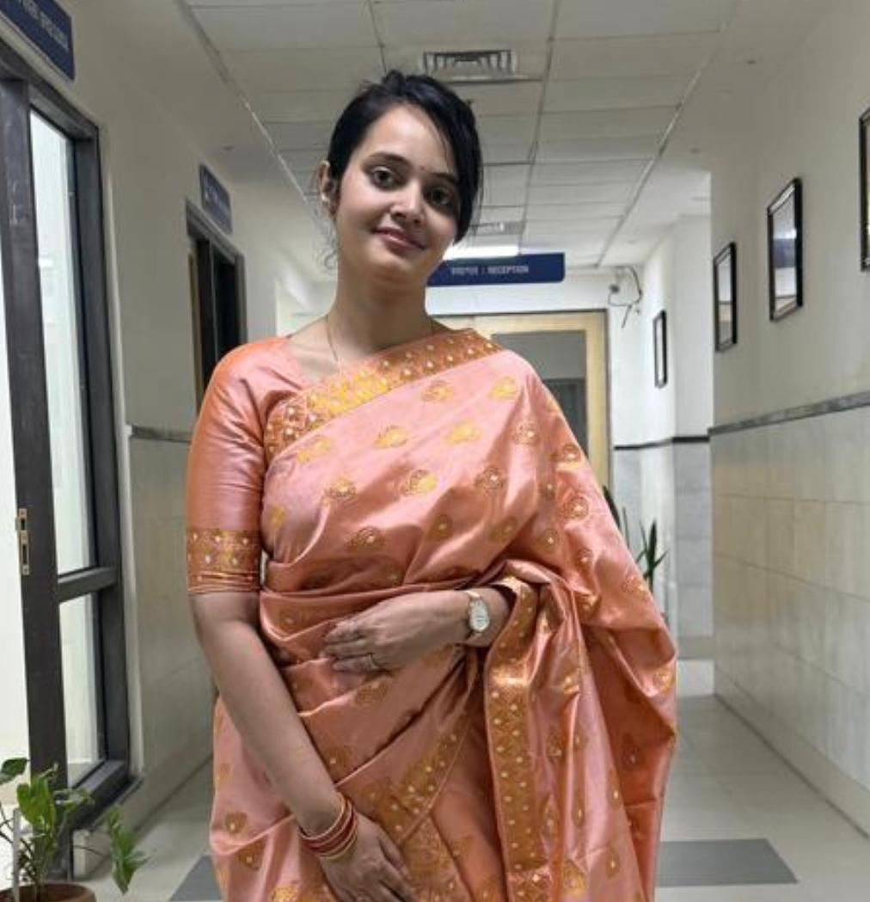
Dr. Upasana Sandilya
Dr. Kirtijit Chakma
Dr. Narmy Thangjam
Dr. K.S.Rishikesh

Junior Residents:
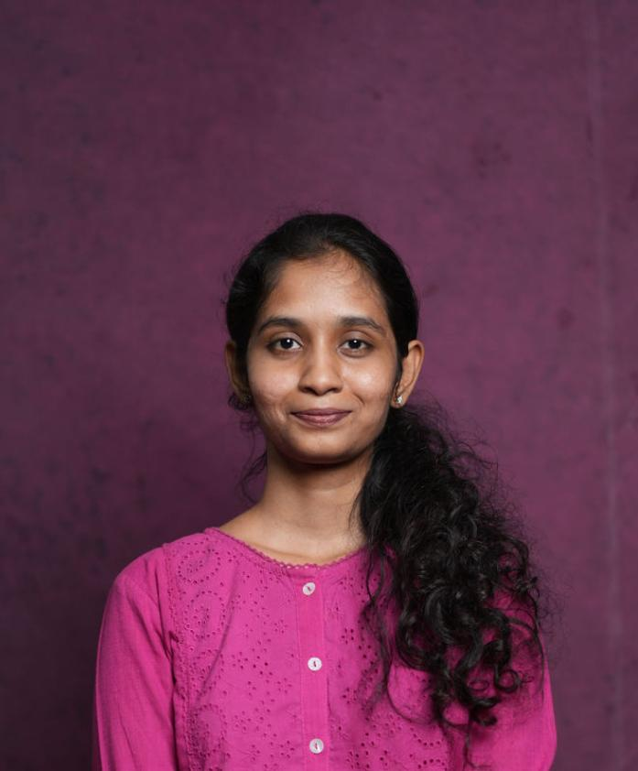
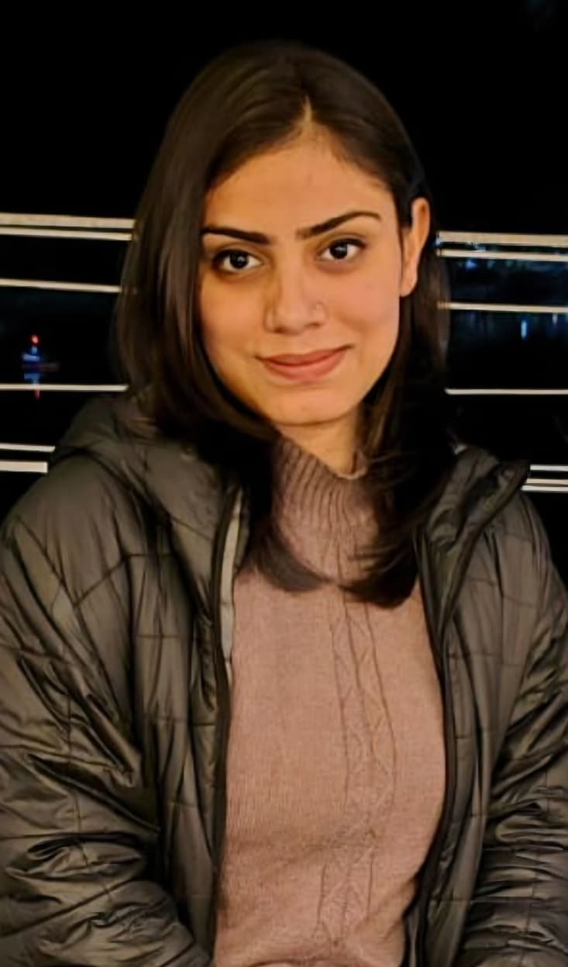
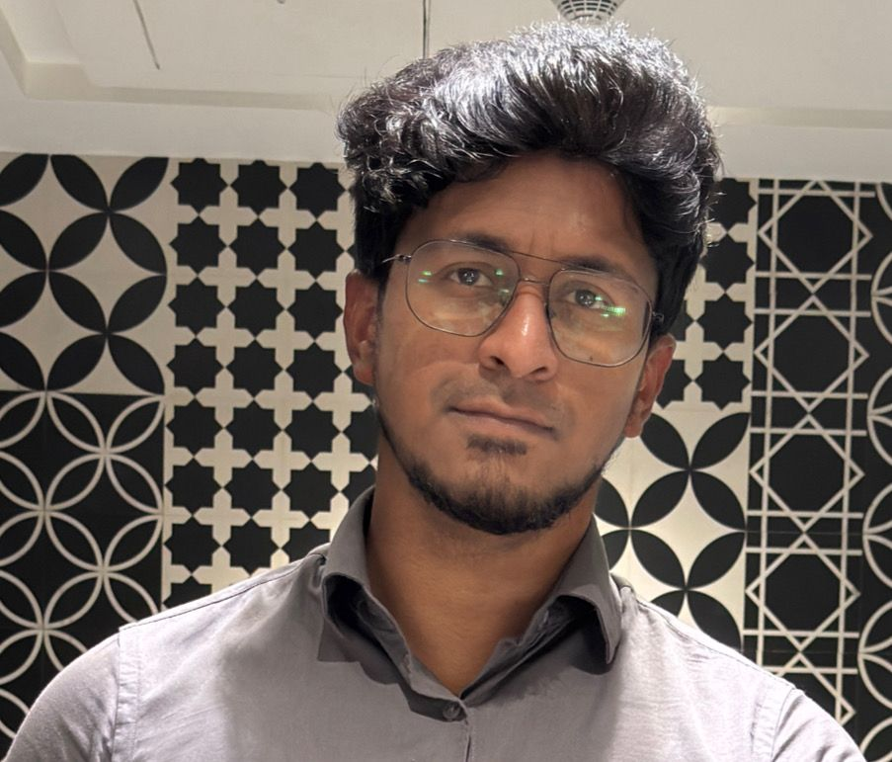
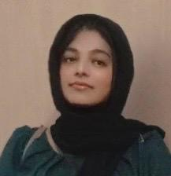
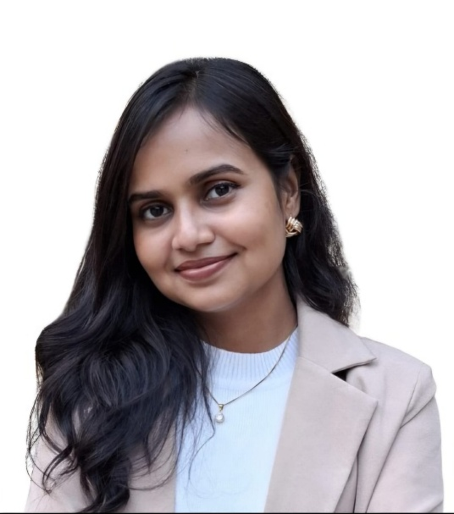
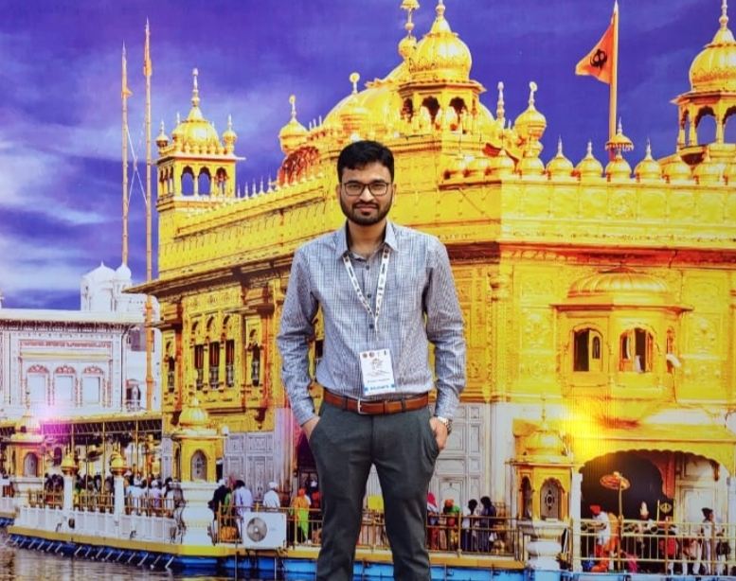
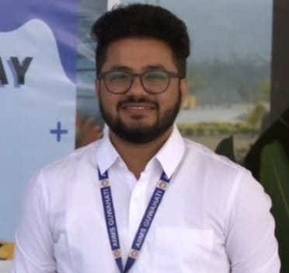
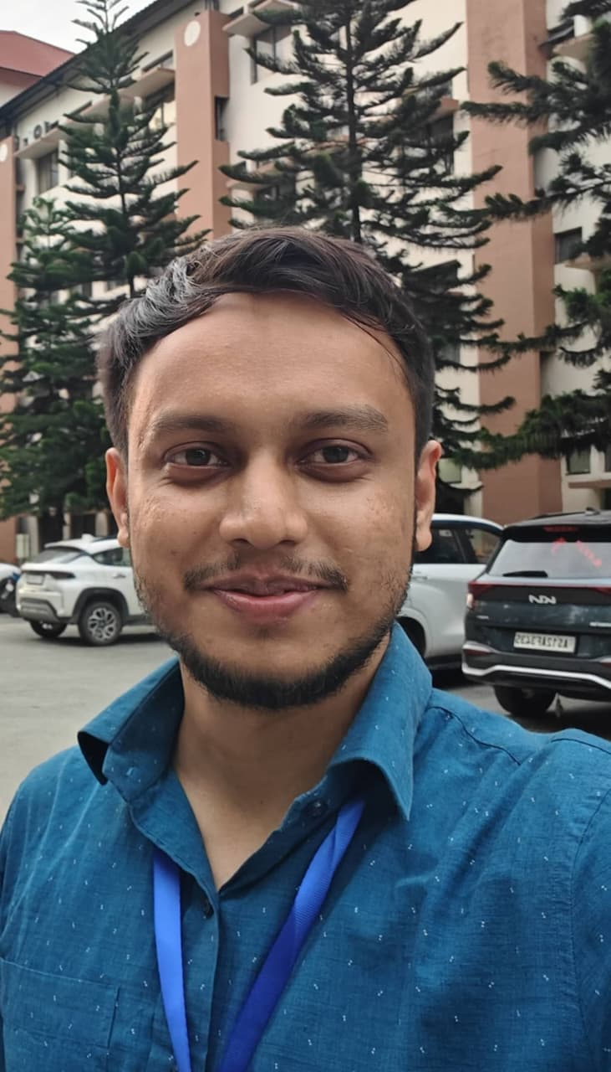
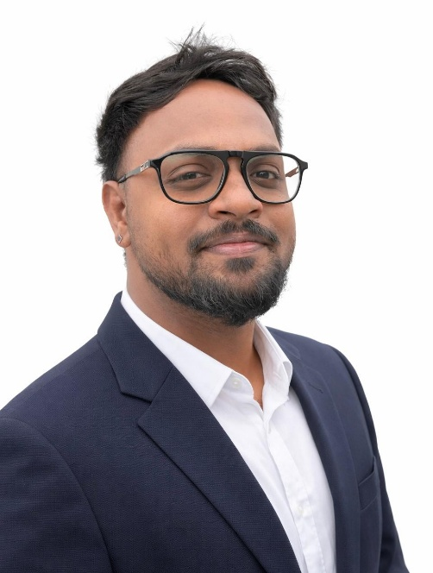
Dr. Srushti Praharshitha
Dr. Kangan Sharma
Dr. Afnas Niyaz
Dr. Madiha Yahya
Dr. Benjina Ahmed
Dr. Pradip Chandra Das
Dr. Shuvankar Srutikar
Dr. Saurabh Chandrakar
Dr. Naveen Nehra

